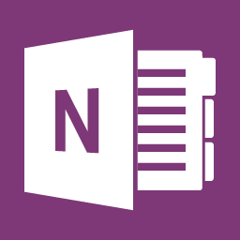
Microsoft OneNote
Advanced

Duration: 1 Day Course
During this training course, participants will receive a deep knowledge of how to use each advanced feature of OneNote, including reviewing the calculator capabilities, working with equations, converting Ink to Math, sorting table contents, and setting proofing language. The course is designed for easy understanding and deep retention of information.
After participating in this highly engaging training course, participants will develop the skills to use OneNote effortlessly to conduct various functions, including syncing notes across computers and devices, saving and sharing files in the cloud, drawing or handwriting notes, collaborating, and embedding Excel spreadsheets and Visio diagrams.

Working with Notebooks
- What You Need to Know About the New File Format
- Using the Notebook Migration Tool
- Password Protecting Your Notebook
- Using OneNote Backups

Formatting and Editing Your Notes
- Applying Styles
- Using the Page Setup Group
- Using Snap to Grid
- About Using Embedded Visio Diagrams
- Resizing and Moving Objects
- Arranging and Rotating Objects

Advanced Sharing Options
- Exporting Your Notes
- Sending Your Notes

Getting Started

- Housekeeping Items
- Pre-Assignment Review
- Workshop Objectives
- The Parking Lot
- Action Plan
Using Additional Notebooks
- Creating a New Notebook
- Opening Notebooks
- Working with Notebook Information and Settings
- Setting OneNote Options
- Working with Audio and Video
- Applying Styles
- Recording Audio
- Recording Video
- Working with Playback Settings

Microsoft OneNote
Advanced

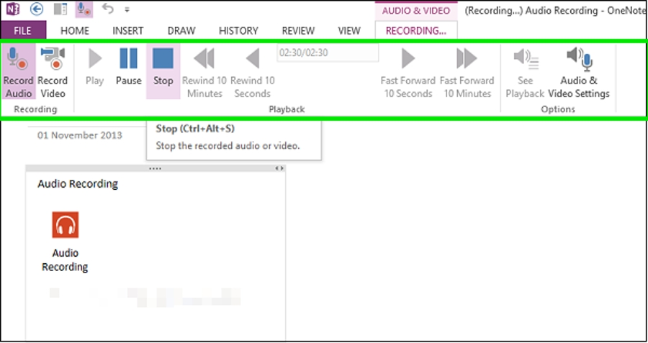
COURSE CONTENT (Contd.)
Working with Equations and Excel Spreadsheets
- Working with Equations
- Understand the Calculator Capabilities
- Inserting an Excel Spreadsheet
- Converting a Table to an Excel Spreadsheet
- Converting Ink to Math

Advanced Review Tasks
- Translating Words or Phrases
- Using the Mini Translator
- Setting Translation and Proofing Languages
- Password Protecting a Section
Working with Tables
- Selecting Rows and Columns
- Inserting Rows and Columns
- Deleting Rows and Columns
- Using Borders and Shading
- Adjusting Table Alignment
- Sorting Table Contents

Wrapping Up
- Words from the Wise
- Parking Lot
- Lessons Learned
- Completion of Action Plans and Evaluations

Researching a Topic
- Using the Research Task Pane
- Make Text in Pictures Searchable
- Starting and Finishing a Linked Notes Session
- View or Remove Linked Notes
- Disable and Re-enable Linked Notes

Collaborating
- Sharing Notebooks with Other Computers and Other Authors
- Understanding Notebook Synchronization Status
- Find By Author
- Taking Meeting Notes

